Wee7 Assignment1
This assignment demonstrates the implementation of Create, Read, Update, and Delete (CRUD) operations using Python with both MongoDB and Neo4j databases. The databases used in this assignment build upon the Child Nutrition databases created in previous modules. MongoDB was used to manage document-oriented data, while Neo4j was used to manage graph-oriented data. Python served as the integration layer that connected to both database systems and executed CRUD operations programmatically.
MongoDB CRUD Operations
The MongoDB database used in this assignment was the childnutrition database that was created and populated during previous assignments. Rather than modifying the original collections (nut_descs, nut_vals, ctgnme, gpcnme, and wght), a dedicated collection named week7crud was created for CRUD testing. This approach protects the integrity of the original Child Nutrition data while still demonstrating successful Create, Read, Update, and Delete operations. The week7crud collection used the same nutrient-based structure as the original database, ensuring consistency with the established data model.
MongoDB Connection
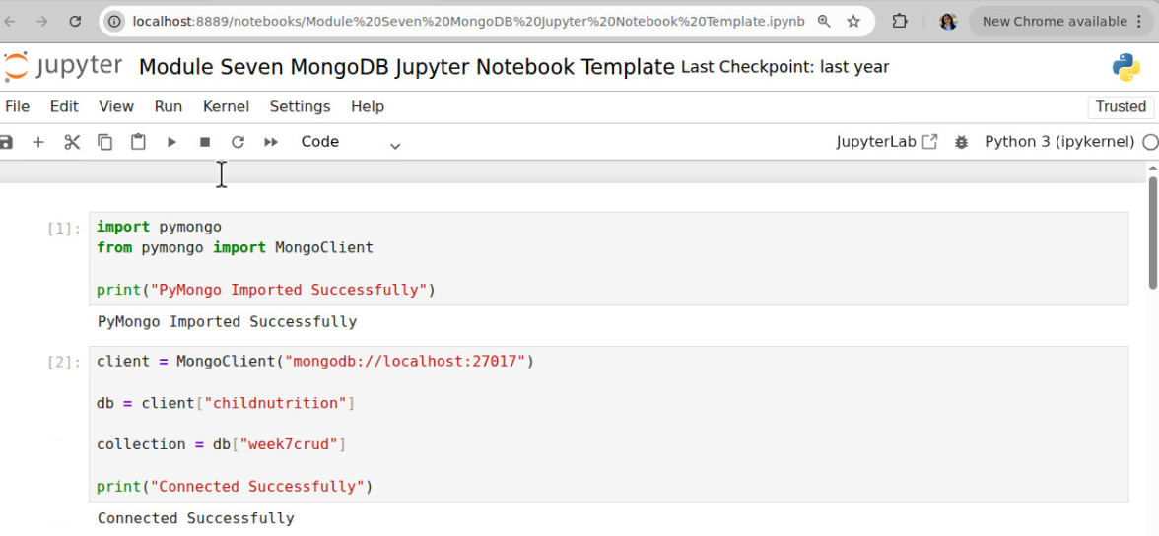
Python was connected to MongoDB using the PyMongo library. The application connected to the existing childnutrition database and accessed the week7crud collection. Using a separate collection ensured that repeated testing could be performed without affecting the imported Child Nutrition datasets used in earlier modules.
Create Operation
The Create operation inserted a new nutrient document into the week7crud collection. The document contained Nutrient Code 777 and represented a Zinc nutrient record. The document included several nutrient-related fields that matched the structure used throughout the Child Nutrition database.
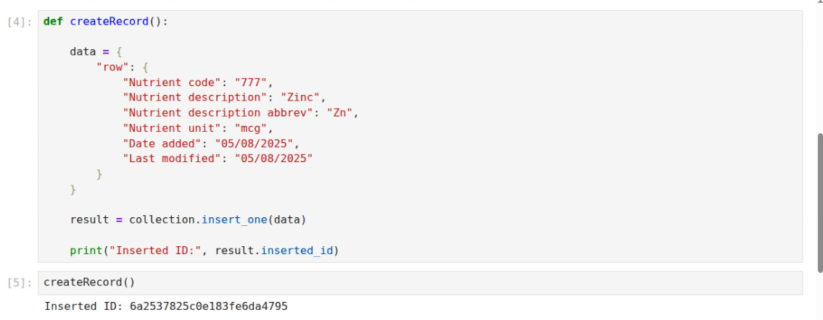
The generated ObjectId confirmed that the document was successfully inserted into MongoDB. The ObjectId serves as a unique identifier and verified that the Create operation completed successfully.
Read Operation
The Read operation retrieved the nutrient document using Nutrient Code 777 as the search criteria.
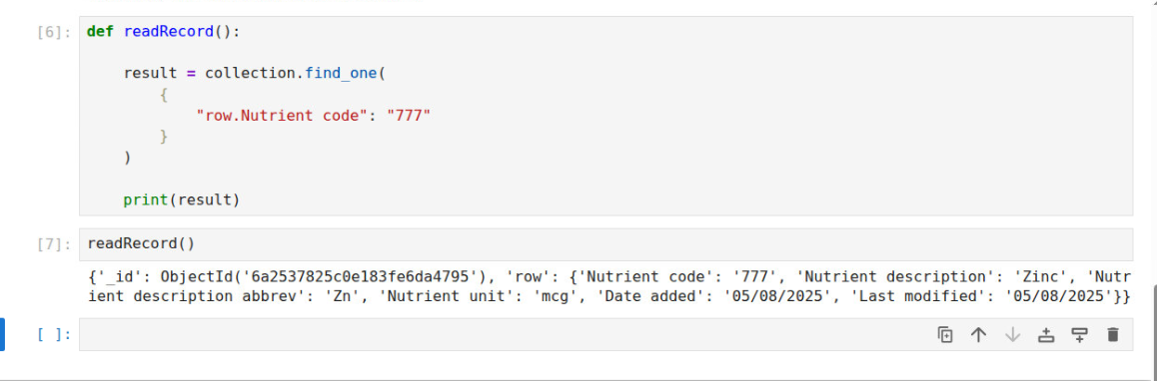
The query returned the exact document that was inserted during the Create operation. The returned values matched the expected nutrient information, confirming that the document was successfully stored and retrieved.
Update Operation
The Update operation modified the Nutrient Description field from "Zinc" to "ZINC UPDATED."
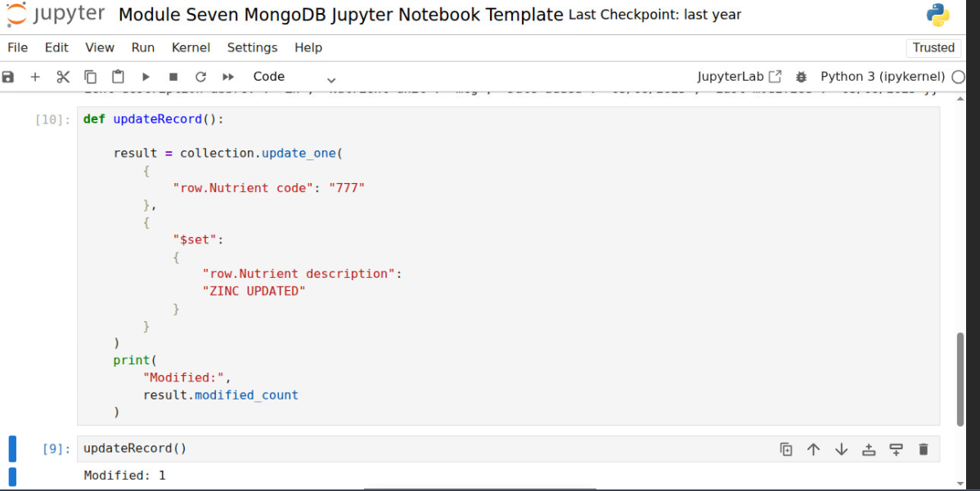
The update operation returned a modified count of 1, indicating that exactly one document was updated. This result matched the expected outcome because only one document contained Nutrient Code 777.
Update Verification
A second Read operation was performed after the update to validate the modification.
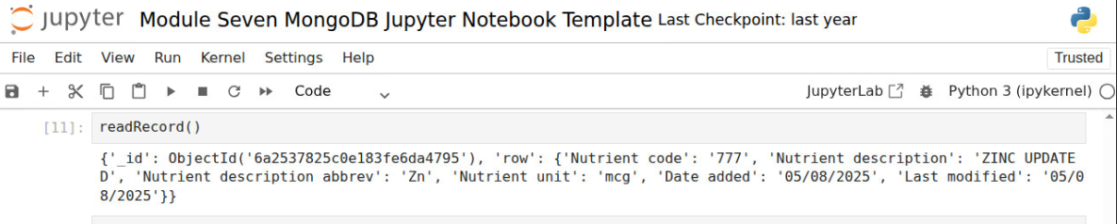
The returned document displayed the updated value "ZINC UPDATED." This verification step confirmed that the update operation successfully modified the target document.
Delete Operation
The Delete operation removed the nutrient document from the week7crud collection.
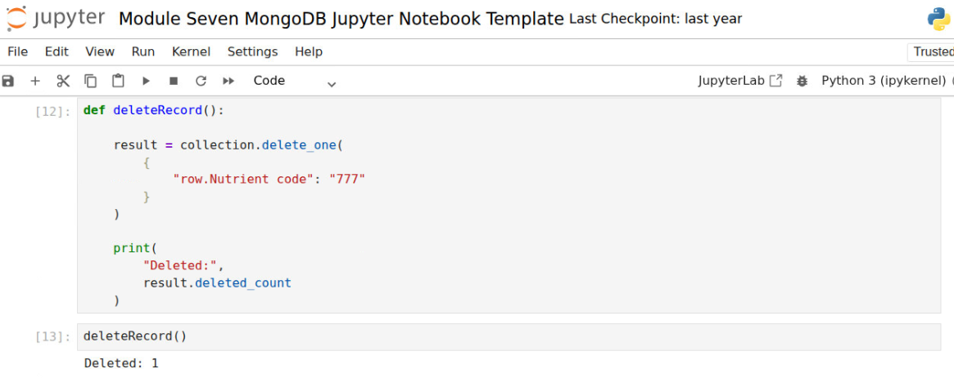
The deleted count of 1 confirmed that exactly one document was removed from the collection.
Delete Verification
A final query was executed to verify that the document no longer existed within MongoDB.
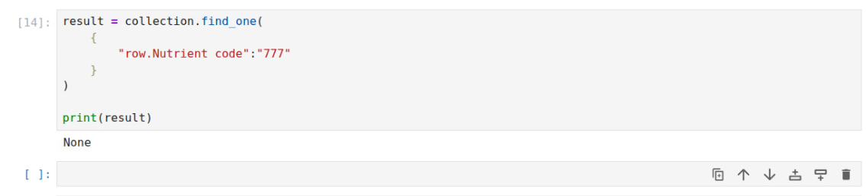
The query returned None, confirming that the document had been permanently removed. This validation step demonstrated that the Delete operation completed successfully.
Neo4j CRUD Operations
The Neo4j database used in this assignment contained the Child Nutrition graph developed in previous modules. The graph included NutDes and NutVal nodes connected through the INSTANCE_OF relationship. CRUD operations were performed on NutDes nodes because they represent nutrient descriptions within the graph schema. Using an existing graph entity rather than creating an unrelated node type demonstrated integration with the established Child Nutrition graph model.
Neo4j Connection
Python was connected to Neo4j using the official Neo4j Python driver. The connection was established using the database configuration file and authenticated with the Neo4j server.
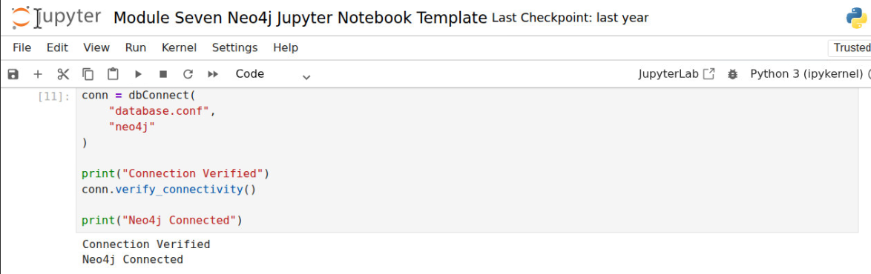
The successful connection verified that Python could communicate with the graph database and execute Cypher statements.
Create Operation
The Create operation used a MERGE statement to create a NutDes node representing Zinc. The node contained properties including NutrientCode, NutrientDescription, NutrientDescriptionAbbrev, NutrientUnit, DateAdded, and LastModified.
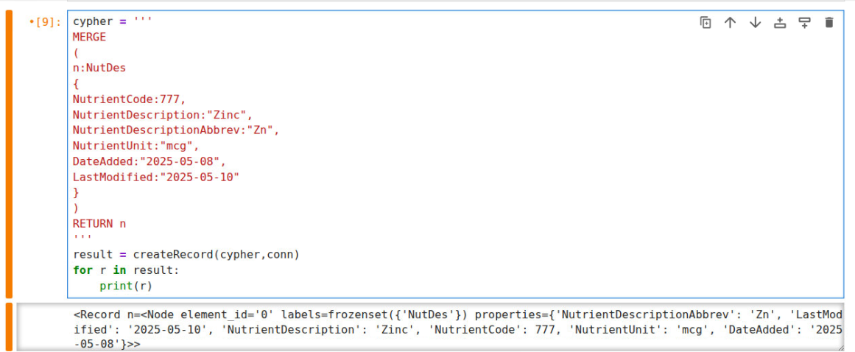
The returned node confirmed that the Create operation successfully added the nutrient description node to the graph database.
Read Operation: The Read operation searched for the NutDes node using NutrientCode 777.
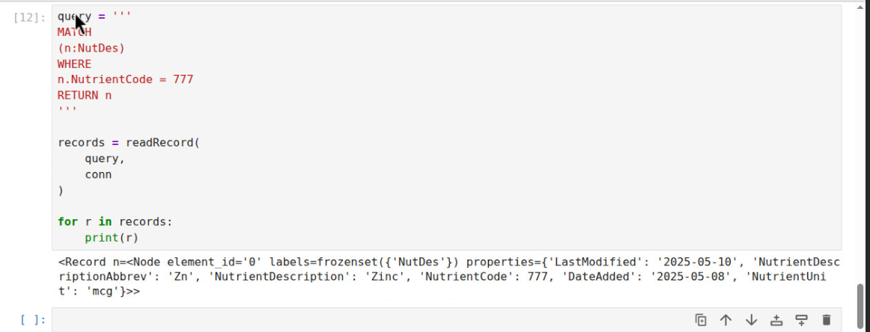
The query returned the Zinc nutrient node. The returned values matched the expected node properties, confirming that the node had been successfully stored in the graph.
Update Operation
The Update operation modified the NutrientDescription property from "Zinc" to "ZINC."
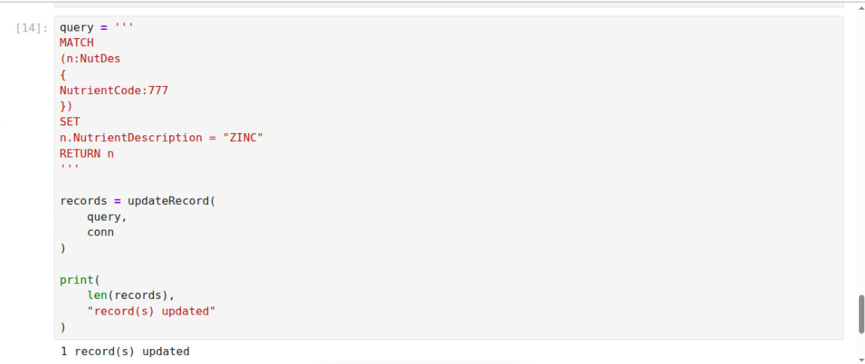
The update query returned one updated node. This result confirmed that the graph database successfully modified the target node.
Update Verification
A second Read operation was executed after the update.
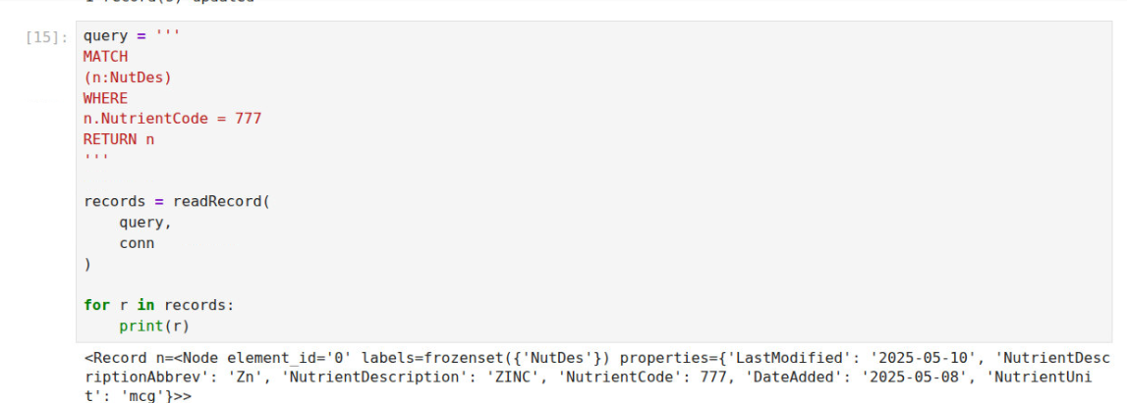
The returned node displayed NutrientDescription as "ZINC." This validation step confirmed that the update operation completed successfully.
Delete Operation
The Delete operation removed the NutDes node from the graph. The delete operation completed successfully and removed the node from the graph database.
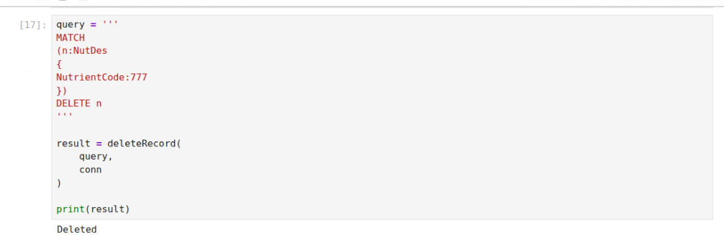
Delete Verification
A final query was executed to verify that the node no longer existed.
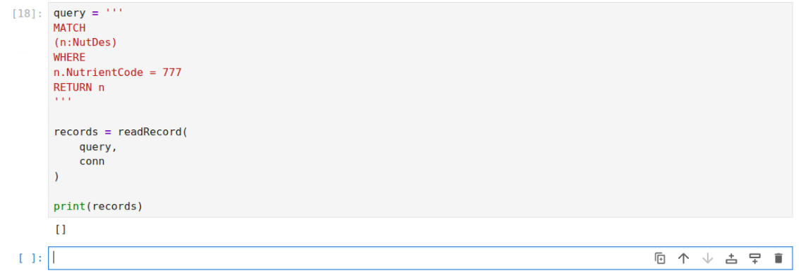
The query returned an empty result set ([]). This result confirmed that the node had been successfully removed from the graph database.
Part Three: Reflection
Circumstances for Using Python ETL
Python would be an effective choice for performing ETL processes when data originates from multiple sources or requires significant transformation before loading into a database. Examples include importing data from CSV files, JSON files, spreadsheets, APIs, and web services. Python provides flexibility, automation, and extensive data-processing libraries that make it suitable for complex ETL workflows. In the Child Nutrition project, Python could be used to transform source data into formats suitable for either MongoDB or Neo4j before loading the information into the database.
a) Complexity of the ETL Process
The complexity of the ETL process depends largely on the structure and quality of the source data. Simple ETL processes may involve reading a CSV file and loading records directly into a database. More complex ETL processes may require data cleansing, datatype conversion, duplicate removal, validation, and relationship creation. For example, date values may need to be converted into standardized formats, nutrient values may need to be converted into numeric datatypes, and graph relationships may need to be established between entities. As transformation requirements increase, the complexity of the ETL process also increases.
b) Impact of Data Source on ETL Decisions
The source of the data would significantly impact ETL decisions. Structured CSV files generally require fewer transformations and are easier to process. JSON files often contain nested structures that require additional parsing before loading. Data obtained from APIs may require authentication, rate-limit handling, and additional validation. Because each data source presents unique challenges, the ETL design must be adapted to ensure consistency, accuracy, and completeness of the imported data.
c) Validation During ETL
Python provides many opportunities to validate data during ETL processing. Validation procedures may include checking for missing values, verifying numeric datatypes, validating date formats, detecting duplicate records, enforcing required fields, and confirming referential integrity between related datasets. Additional validation could include range checking for nutrient values and verifying that relationship keys exist before graph relationships are created. These validation techniques improve data quality and reduce the likelihood of loading incorrect information into MongoDB or Neo4j.
d) Most Efficient ETL Method
From a performance perspective, native database import tools are generally more efficient than Python ETL scripts. Tools such as mongoimport for MongoDB and LOAD CSV for Neo4j are optimized for bulk loading large datasets and typically execute faster than custom Python code. However, Python ETL processes provide greater flexibility because they allow complex transformations, validation procedures, and business-rule enforcement before data is loaded. Therefore, native import tools are usually preferred when performance is the primary objective, while Python ETL processes are preferred when data quality, validation, and transformation requirements are more important.

